

CRIME
YOU ARE THE EYES AND EARS
PREVENTION

ONE OF THE MAIN POINTS OF BEING IN A NEIGHBOURHOOD WATCH SCHEME IS TO
PREVENT CRIME
TO DO THIS YOU HAVE TO GET TO KNOW AND WORK WITH
OTHER HOUSEHOLDS IN THE SCHEME.
When they are
out at work
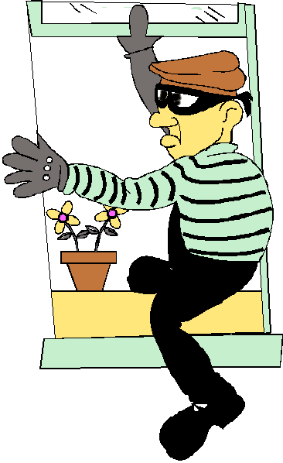
Check if their burglar
alarm is activated
Going on holiday?
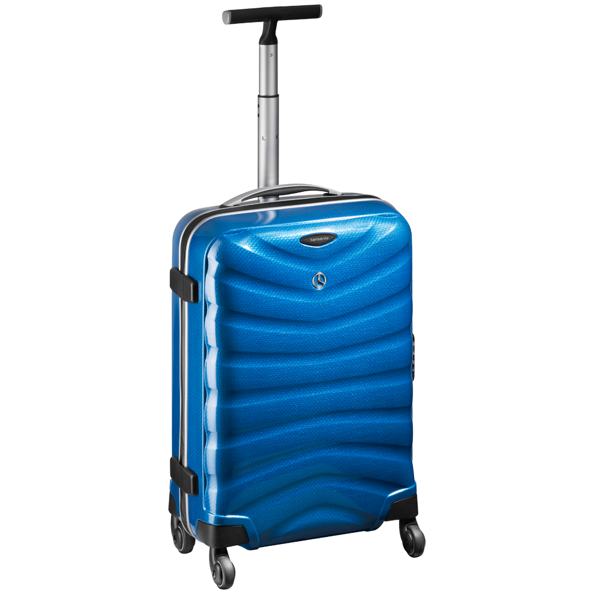
Leave contact details with your neighbour or NHW Co-ordinator

Do not leave car keys near front doors
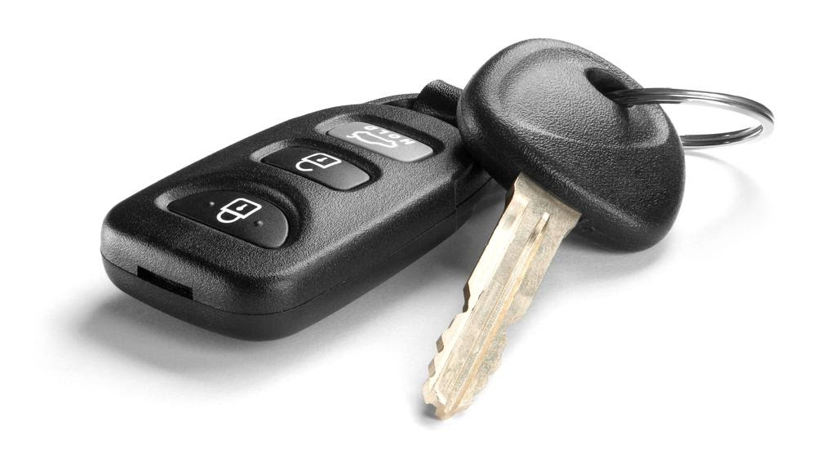
Preferably Put them in a metal box to prevent cloning
Ensure outhouses and sheds Are securely locked
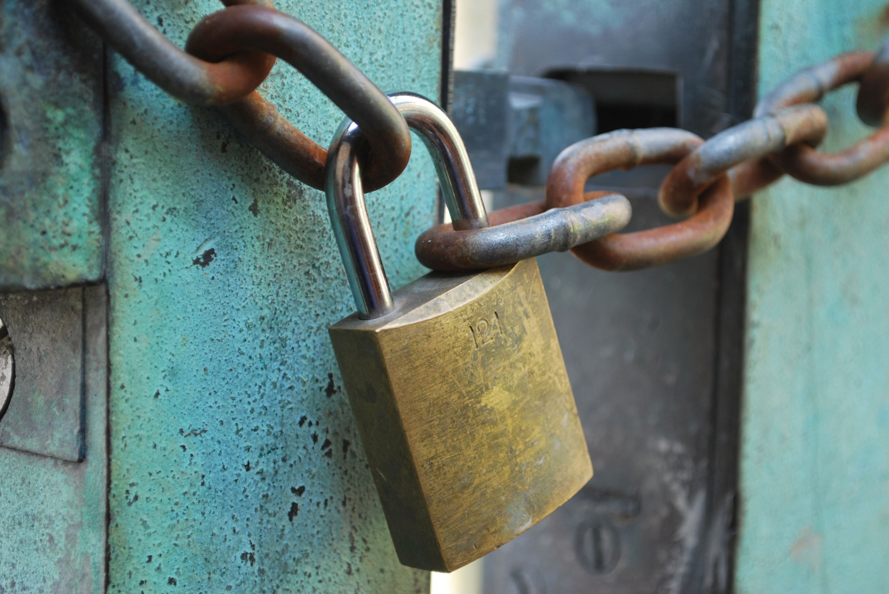
Along with valuables such as bicycles

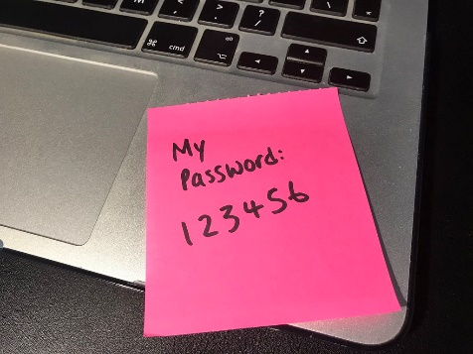

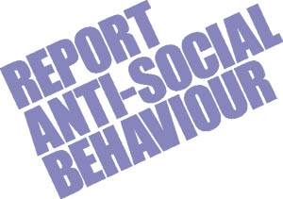
A FEW OTHER
THINGS TO BEAR
IN MIND
LOOK AFTER YOUR WALLETS / HANDBAGS / PHONES WHEN IN PUBLIC
BACK POCKETS SHOULD BE AVOIDED SHOULDER BAGS SLUNG OVER YOUR SHOULDER ARE MORE SNATCH PROOF
DO NOT LEAVE THEM SLUNG OVER BACKS OF CHAIRS IN RESTAURANTS & PUBS
Ensure you have a strong & different passwords.
BE AWARE OF PHONE AND EMAIL SCAMS
CONSIDER NOT ANSWERING ANY UNKNOWN CALLERS
AGAIN REPORT ANY ATTEMPTS TO EITHER PHONE COMPANY OR FIRM THE CALL / EMAIL PURPORTS TO COME FROM
YOU MIGHT NOT WANT TO / OR BE ADVISED NOT TO GET INVOLVED BUT
CONSIDER TAKING PHOTO OF INCIDENT AND REPORTING IT TO THE POLICE

